You should work with a partner on this exploration.
In Exploration I you considered rational functions and their vertical asymptotes. In this exploration we are interested in finding guidelines for horizontal asymptotes as well. The printed example you were given with Exploration I was the graph of and it had a horizontal asymptote of (the x-axis). Using the expand feature of the TI-89 this can also be written . To get you started, compare this to graphed below.
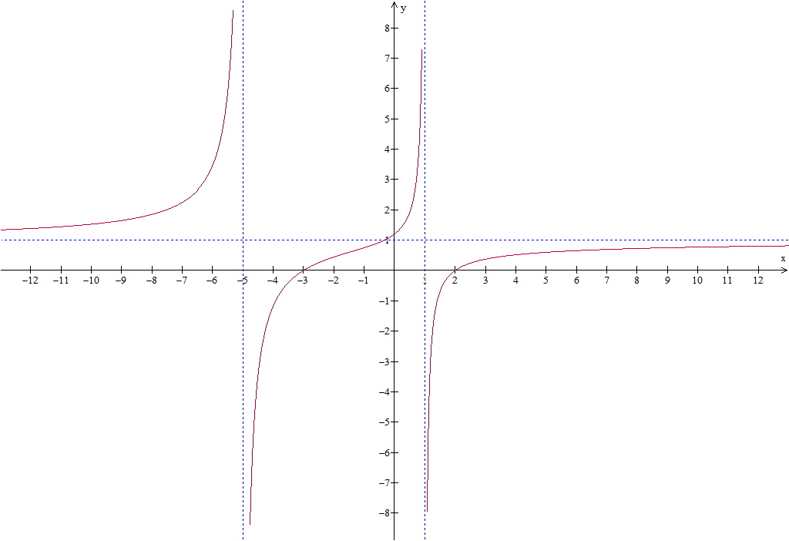
The above graph has vertical asymptotes:
and
The above graph has horizontal asymptote:
For this exploration you are to ask your own questions to investigate that leads you to your conclusions on finding horizontal asymptotes. Write those questions and ideas down as you explore them on the extra sheets provided, sketching what you get and any conclusion you find. Hopefully your first exploration will lead you to other questions that you will write down and explore. When you are finally done you should have a list of Guidelines for Finding Asymptotes. (Separate pages are provided for explorations but not attached, as each group may have a different number of examples they explore.)
Challenge: Explain the mathematics they justifies your conclusion.

State your final conclusions below.
General Guidelines for Asymptotes of Rational Functions

Exploration

Exploration

